Year 5/6 Homework Activities: ‘Up, Up and Away’
Computing |  | Literacy | PE |  | Maths
Research The Wright Brothers. Who were they and why are they important?  Make a PowerPoint to present the information you find.  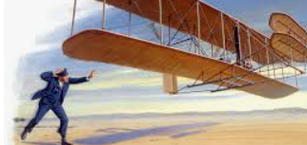 |  | Create your own plane top trumps pack. Try and include traits such as top speed and wing span.  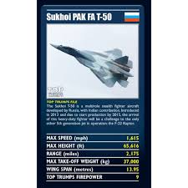 | Complete the Space X mission exercises and record what you found. This is the first step in becoming an astronaut.  See link:  https://trainlikeanastronaut.org/activities/?_activity_filters=physical  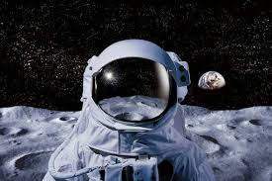 |  | After completing the Science experiment, complete a graph showing how 3 different objects fall at different speeds. They would of all been dropped from the same height.  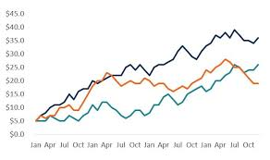  You will need to identify an independent and dependent variable.
Literacy/History | Maths/Science |  |  | D&T | Art
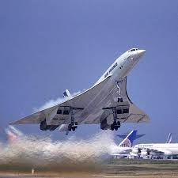  Research about Concorde and write a balanced argument on why you think it should be allowed back in the sky. | You need to complete an experiment. Choose 3 different items and see how long it takes each of them to drop. Record the times in a table as you will need these for your graphs.  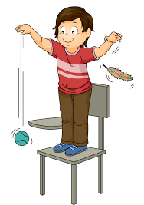  Remember, each object must be dropped from the SAME height. You also need to find out how much they weigh.  Be creative with the objects you choose. |  |  | Design and Make  Build a 3D model of a plane of your choice. It can be as simple as lollipop sticks to as complicated as you would like. I want this to impress me.  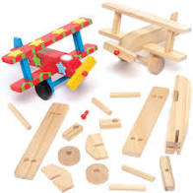 | Create a masterpiece entitled “Flight”.  You can use any medium (paint, pen, pencil, collage, clay etc.)  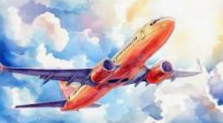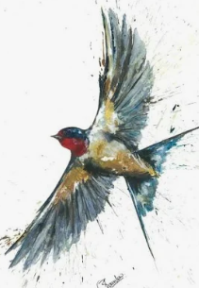

Homework is due in by Monday 14th December to enable us to share and celebrate this work in the final week of our topic.
We expect: Yr 6 to complete a minimum of 5 of these activities and Yr 5 to complete a minimum of 4.
Remember other ongoing homework, such as your spelling, reading and TTRS.
If you need help sourcing anything to complete any of the homework tasks please speak to your class teacher.

