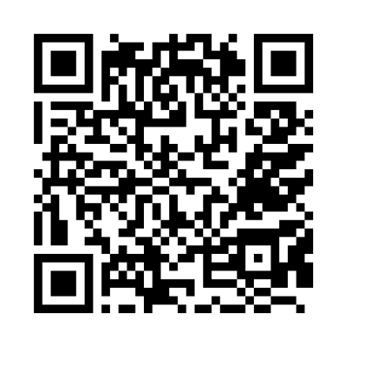
Set 2 sounds
ay
https://schools.ruthmiskin.com/training/view/pI38Sukc/YSLGtDUn

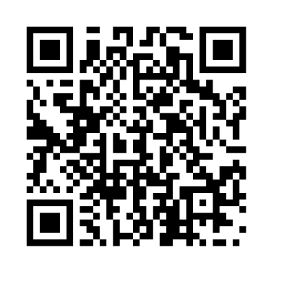
ee https://schools.ruthmiskin.com/training/view/ZAau1rWf/oVtedcJC

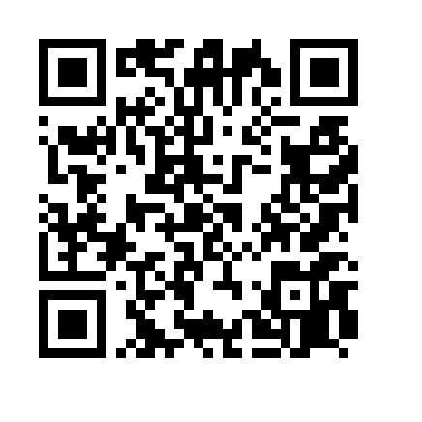
igh
https://schools.ruthmiskin.com/training/view/lW3ZCcCB/45lnigBb
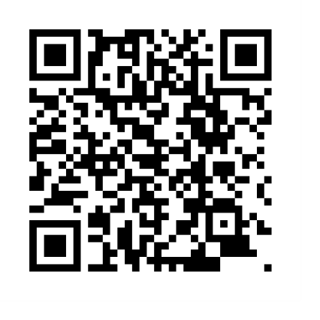
ow https://schools.ruthmiskin.com/training/view/1zAFyAct/yXC02mAb
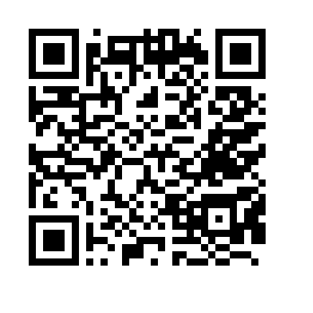

oo
https://schools.ruthmiskin.com/training/view/LlGtNlvr/xVHBXjwp

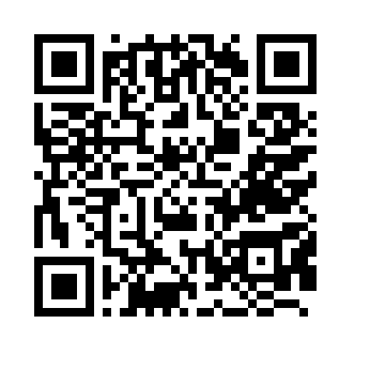
oo ‘look at a book’
https://schools.ruthmiskin.com/training/view/IWYHAKKF/dheKMMor

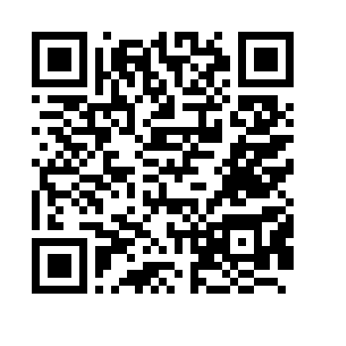
ar
https://schools.ruthmiskin.com/training/view/0Z7UCo6A/9HVJST3q

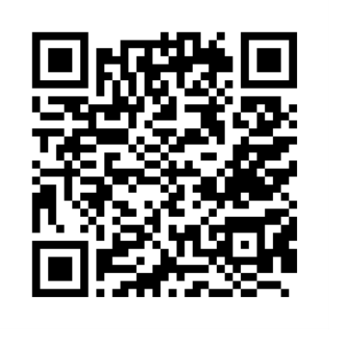
or
https://schools.ruthmiskin.com/training/view/UmKlhHv2/n8aPftGy
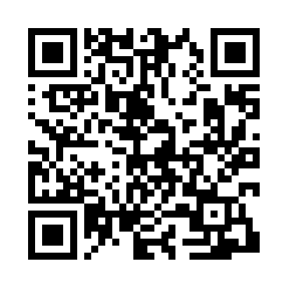
air
https://schools.ruthmiskin.com/training/view/GQy9f9Up/HFVycDiI

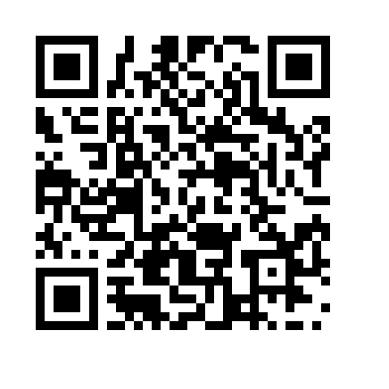
ir
https://schools.ruthmiskin.com/training/view/kUT9PMQm/aUKHWL7H

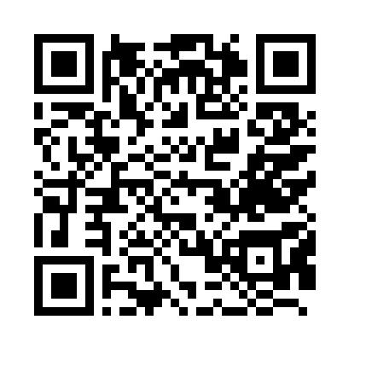
ou
https://schools.ruthmiskin.com/training/view/rULhJEOk/iMN6BcDB

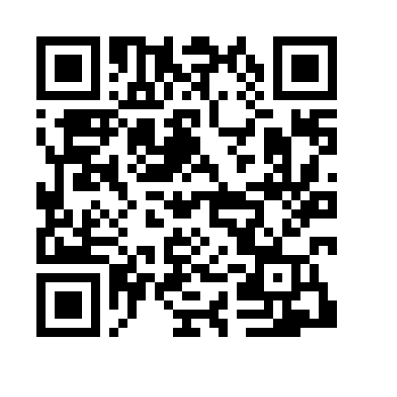
oy
https://schools.ruthmiskin.com/training/view/tXNyeVtS/EYTUyaY5

