Newsletter

Dear Parents/Carers,

It has been another wonderful week in school.

This week we wanted to take the opportunity to remind families of our attendance policy. Here is the link to find our updated policy on the school website - Bourton-Primary-Attendance-Policy-2026.400361072.docx. However, if you are not reading the online version and need to find the policy, it is under the school information tab and school policies.
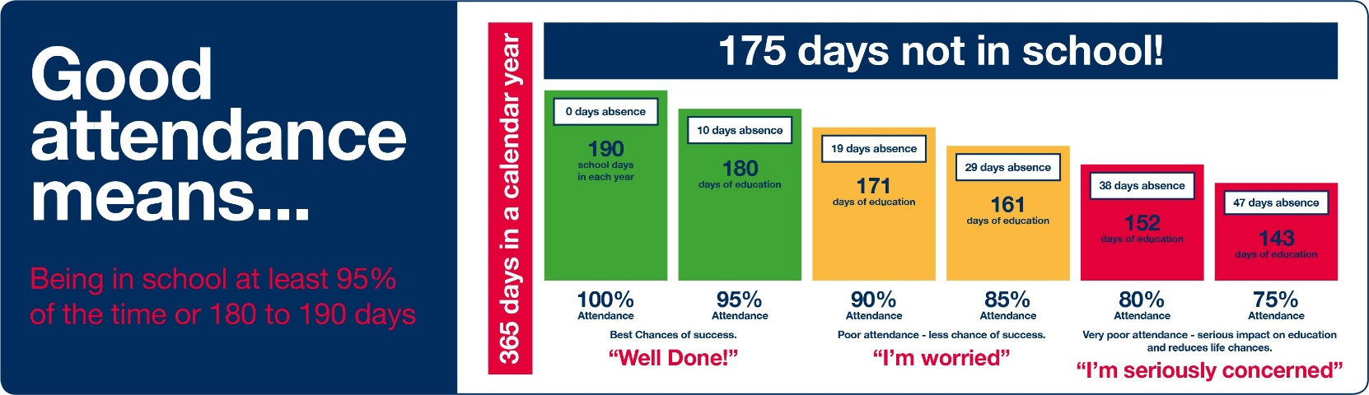

Research tells us how important attendance is to our children’s progress, and with new guidance released from the DfE in July about the importance of attendance, we wanted to introduce an attendance award that the children can receive weekly. We understand that any child can have their attendance effected by illness, which is why our attendance award will not just celebrate good attendance, but also where any attendance achievements have been made. This could range from resilience returning after an illness, improved attendance overall or even celebrating another child’s attendance and helping to create a positive culture about attendance. If you have any questions about attendance, please ask your class teachers, ourselves or pop in and see our Attendance Champion, Mags, in the office.

Next week, Year 6 will be off on their PGL adventure. This time away not only allows the children to be independent and build lasting memories and bonds with their peers, but also allows the children to take risks with their learning, and have enriching experiences that will give them excellent opportunities to try new things. We know they will have an amazing time, and can’t wait to hear all about it.

Remember to sign up for clubs on iPal as these are due to start next week. We have a broad range of activities that support many areas of the curriculum from, PE, to Science and Art to name a few, and they remain fully-funded by the school at no extra expense to our families.

Have a wonderful weekend,

Mrs Kilbey & Mrs Connor
Co Headteachers

