Year 5/6 Homework Activities Autumn: Bustling Bourton
Geography |  | Literacy | History |  | Science
Create a fun fact file about Bourton today: eg populations, types of business, different tourist attractions etc  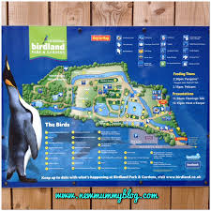 |  | Write a poem describing water movement – think of the River Windrush.    Use good powerful vocabulary, similes, metaphors, personification. | Create some questions & interview a Bourton resident about how Bourton has changed in their lifetime.   |  | Research and write (with diagrams) an explanation as to how shadows or reflections occur.  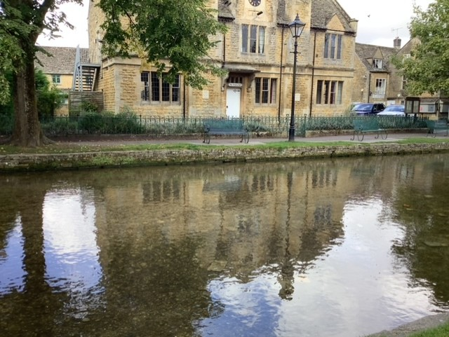
Art | History |  |  | Art | History
Draw or paint an object thinking carefully about including shadows (consider where the light source is).  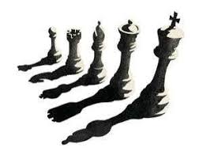 | Family research.  Find out about the history of your family – can you make a family tree?  Present this information in any way you that like!  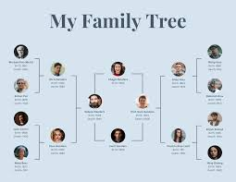 |  |  | Sketch/paint a picture of an interesting building in Bourton or a local village to where you live.  Make sure you include lots of detail!  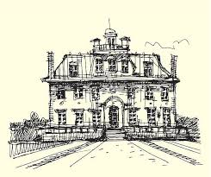 | Cotswold Traditions!  Research one or several different traditions that are special to the Cotswolds eg Football in the river, Cotswold Olympics…  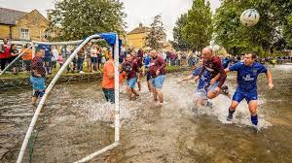
Homework is due in by Monday 12th October to enable us to share and celebrate this work in the final week of our topic.
We expect everybody complete a minimum of 5 activities.
Remember other ongoing homework, such as your spelling, reading and TTRS.
If you need help sourcing anything to complete any of the homework tasks please speak to your class teacher.

