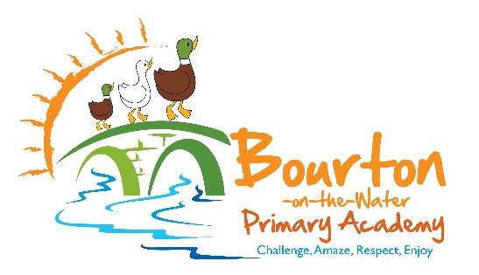
Bourton on the Water Primary School
School Hill, Bourton-on-the-Water, GL54 2AW
01451 820458 admin@bourton.school
Co Headteachers: Mrs Lindsay Connor & Mrs J Kilbey
Preschool Leader: Mrs Lisa Sorley
Preschool: 07950 048 066
Tuesday, 09 June 2026
New Starters 2025-2026
Dear Parents,
On behalf of everyone at Bourton-on-the-Water Primary Academy, we would like to wish a warm welcome to our wonderful new cohort of children who will be transitioning into Reception during the next academic year. It will be a real pleasure to get to know all of our new reception families that are joining us.
This is one of our favourite times of the year, getting to meet you and your amazing children and starting their school journey. Our induction begins with an information meeting where you would meet our Reception Class staff and they would share useful information with you about your child starting school.
We hope that you find the next few pages informative. Please read this whole booklet, then sign the permission slips, and return them to school by Friday 30th June 2026.
If you have any questions, please feel free to contact our administration team in the office, your child’s teacher or a member of the Senior Management Team at any time.
Also, please browse through the other pages on our school website to find out more about our school and community.
Yours sincerely,
Lindsay Connor & Jo Kilbey
Co Headteachers
THE TYPICAL SCHOOL DAY
The day begins at 8:45 when the gates to the Avenue entrance are opened and the children are welcomed into school. A member of staff is on duty at the gate onto the playground and many parents leave children at that point. To avoid unknown adults entering school, we ask parents and carers to say their goodbyes to children outside and for children to come into classrooms without parents. Any parent wishing to visit the school office must enter via the office entrance. The parents from Reception children may accompany their children into their class. The class teacher will be at the door to greet you and your child.
We register the children at 8:55, therefore, it is important to arrive punctually to ensure your child has a calm start to the day. After registration and assembly, lessons begin. Generally English and Maths lessons make up the morning, but there is a recreation break for all pupils for 15 to 20 minutes, sometime between 10:20 am and 11:00 am, depending on age. We stagger playtimes in order to give children as much room to run about in.
Lunch periods start from 12:15 for about an hour. All Reception, Year 1 and Year 2 children may have a lunch free of charge, called a Universal School Meal, but please note this is not the same as a free school meal entitlement. Families with an entitlement to free school meals receive other support as part of the welfare benefits system. The school also receives additional funding from central Government to support these pupils.
After lunch, the children return to class for afternoon learning before being dismissed at 3:15pm. From 3:10pm, the gates from the Avenue are opened and parents congregate on the MUGA playground and wait for their children to be dismissed to them.

SCHOOL UNIFORM
School uniform promotes a sense of togetherness and belonging as it differentiates between Bourton Primary children and children from other schools. Our school colours are grey, white and burgundy red. We require all children, while at school, to wear school uniform or school colours. We have no school policy for coats. Sensible shoes must be worn and for safety reasons, no backless shoes, crocs or high heels are permitted. All new Reception, Year 1 & 2 pupils to our school are provided with a book bag, which is funded through our parent’s association, FoBS (Friends of Bourton School).
Our school uniform consists of:
- A burgundy red sweatshirt or cardigan with the school logo.
- A white polo shirt with or without the school logo.
- A grey skirt, pinafore dress or smart dark trousers.
- Grey trousers or shorts.
- Black shoes.
- Red checked summer dresses.
Optional: reversible shower jacket with the school logo.

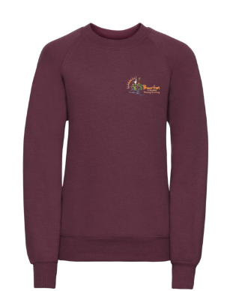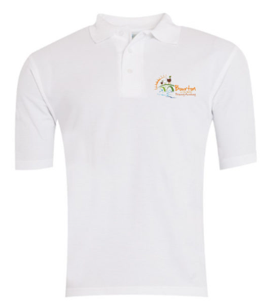

PE KIT
PE is a compulsory part of education and it is important that children are dressed correctly for it. Indoor and outdoor lessons are planned throughout the year, so all pupils must have a PE kit as listed below. Official school PE kit can be purchased but this is not compulsory although we do ask that you purchase a PE Shirt with the school logo.
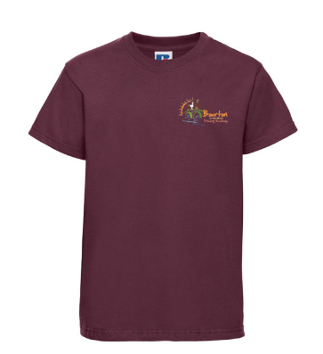
Optional: Black jogging bottoms (as well as black shorts)
JEWELLERY
The accidental pulling and catching of earrings, rings and necklaces during play or PE can cause severe damage to fingers and /or earlobes. Although a plain stud is acceptable, other jewellery is not permitted. Children will still be required to remove studs or tape over them during PE. The school cannot accept responsibility for the loss or damage of items of jewellery or watches. Hair should be tied back.
CREATIVE ACTIVITIES
Please provide a named apron or overall for creative activities for children in Reception, we do have some in the classrooms.
It is important that all clothes are clearly marked with the child’s name.
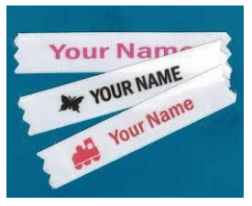

ILLNESS AND MEDICINES
We can give medicine at school for long term complaints such as asthma, or if your child has prescribed medicine following an illness. Ideally, medicine should be given at home if possible. The medicine must be in the original prescription bottle, labelled with child’s name and dosage. We will also ask you to complete a medicine form from the school office. If your child is unwell and unable to attend school, please phone the school office before 8.55am and let us know why they are off. If they have sickness and/or diarrhoea they must stay off school for 48 hours after the last incident. If you are not sure whether your child can attend school, please ask in the school office for advice.
ACCIDENTS AND INJURIES
We have several members of staff that are first aid trained, and a qualified first aider always goes on any out of school learning. They will deal with any bumps, bruises or injuries. Staff may also need to make a decision about whether children are well enough to stay at school. In making this decision we consider the physical condition of the child as well as their emotional well-being. These decisions can be hard to make, we act in “loco parentis” and with the well-being of the child as the most important factor. If children are unwell or have an accident, parents or other emergency contacts will be phoned and asked to collect them. It is therefore essential that you keep us informed of current contact numbers. An accident form will be sent home with your child if he/she has had a bump to the head or any other injury that requires treatment.
UNIVERSAL SCHOOL MEALS
Since September 2014, we have been providing a school meal, free of charge, to all Reception, Year 1 and Year 2 pupils. This is called a Universal meal. This is different to the free school meals service currently offered to all pupils whose parents are in receipt of qualifying benefits. Free School meals entitlement provides extra funding to the school which we use to provide intervention support across the school.
PLAYGROUND
We encourage children to use their bikes and scooters to come to school. However, in order to ensure that all children are safe on site we request the following:
• Bikes and scooters are pushed along the pathways at all times.
• Bikes and scooters are placed in the bike park.
• Bikes and scooters are not used on the playground after school.
• Please ensure you are with your child and take full responsibility for them before and after school.
Please remind your child of these rules to prevent any accidents. These rules are regularly reviewed to ensure safety on the school site. Please could we also request that School’s equipment is not used before or after school.
HOME TIME
We understand that there will be occasions where you have arranged for friends or relatives to collect your child at the end of the day. Please ensure you let us know who will be collecting your child on your behalf, in writing to the teacher or school office. We will not be able to release your child to someone other than you without your consent to do so.
ROAD SAFETY
For the Health and Safety of the children we encourage children to walk to school. However, we appreciate this isn’t always possible. If you do arrive by car, please park in the car park at the bottom of the Avenue (high street car park) or The Legion Car Park and walk up the Avenue to school. There is an active Road Traffic Order that prohibits cars from stopping on the zig-zag lines, double yellow lines or parking near the school gate. We have a bicycle/scooter stand near the main hall for children to store their equipment if they use them to travel to school.

BREAKFAST CLUB AND AFTER SCHOOL CARE
We offer a breakfast club and after school club as wrap around care at our school. Breakfast club is from 8.00-8.45am and the after-school care runs from 3.15-6.00pm. There is more information about this service on our school website.
EXTRA SCHOOL ACTIVITIES
After school each day, teachers may voluntarily run a school club ranging from the arts to sports. Obviously, these clubs are limited in number, so every ten weeks or so we do try to change them around. These clubs are purely optional and we thank the staff for doing them. Clubs run by outside agencies may incur a cost and whilst we are happy to offer these, we do not monitor their quality (other than for safety) and take no responsibility for them.
EDUCATIONAL VISITS
As part of our Curriculum, we may need to take the children out to explore the local area using the consent slip completed when your child joined the school. The visits are risk assessed prior to going out. For trips further-a-field, a specific letter and permission will be sent out.

CONSENT TO USE IMAGES OR PHOTOGRAPHS
Often, we use photos of children on our web site or Facebook feed but never put a name to that picture. From time to time, local or regional press or television may approach our school to take pictures of children if, for example, there has been a particular event at the school that they wish to cover.
The School takes the issue of child safety extremely seriously and that includes the use of images of children. It may be that, for personal or other reasons, you do not want an image or photograph of your child to be taken for publicity purposes and so it is extremely important that your school has a signed form to make your wishes clear.
HOW CAN I FIND OUT HOW MY CHILD IS GETTING ON?
At Bourton-on-the-water Primary we have an ‘Open Door Policy’. This means that you are always welcome to come into school if you have any queries or worries, however small they may seem. The time schedule for the morning is very limited and we are busy with the children so we ask that you try to see us after school.
It is important that you and the professionals caring for your child work together. You need to feel comfortable about exchanging information and discussing things that will benefit your child. You will have parents’ evenings in the Autumn and Spring term when you can talk about your child’s development. You will have a written report at the end of the year, when you will have information about how your child is doing. When your child starts school, teachers will assess your child’s strengths, this will help them to support their development throughout the year.

HOMEWORK GUIDELINES FOR PARENTS
The purpose of Homework is threefold:
- to develop an effective, home-school partnership to help the pupil learn
- to reinforce learning which has taken place in school
- to develop the skills and attitudes of independent study in readiness for lifelong learning
Reception | Phonics 10 minutes a day (Red words and Reading come later in year)  Numbots
Years  1 & 2 | Reading  Numbots  Termly grid with topic activities
Years  3 & 4 | Weekly Spellings/Reading  Times Table Rockstars  Termly grid with topic activities
Years  5 & 6 | Weekly Spellings/Reading  Times Table Rockstars  Termly grid with topic activities
INTERNET SAFETY
Early Years and Key Stage 1 Pupils
Think then Click
These rules help us to stay safe on the Internet
 | We only use the internet when an adult is with us
 | We can click on the buttons or links when we know what they do. | 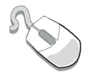
 | We can search the Internet with an adult.
 | We always ask if we get lost on the Internet. | 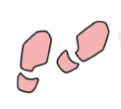
 | We can send and open emails together. | 
 | We can write polite and friendly emails to people that we know.
Key Stage 2 Pupils
- We ask permission before using the Internet in class.
- We only use websites that an adult has chosen for us.
- We tell an adult immediately if we see anything we are uncomfortable with and immediately close any webpage we are not sure about.
- We only e-mail people an adult has approved.
- We send e-mails that are polite and friendly.
- We never give out personal information or passwords.
- We never arrange to meet anyone we don’t know.
- We do not open e-mails sent by anyone we don’t know.
- We do not use Internet chat rooms or social media.
- We abide by age restrictions

From time-to-time breaches in our school’s firewall have occurred. At these times, we close down the internet to pupils and run diagnostic checks.

Home School Agreement
1. The School agrees to:
- understand the needs of all pupils of all abilities
- provide a full and balanced curriculum encouraging each pupil to reach his or her full potential
- have high expectations of its pupils’ success
- provide information and records about the pupil’s educational progress, as well as the pupil’s development in practical and social skills
- arrange regular (every ten weeks or so) meetings with the pupil’s teacher(s) and to ensure teachers are available after school to receive appointments as arranged.
- let the parent know immediately of any serious difficulties encountered by the pupil at school including, academic, emotional or poor attendance
- provide information about education benefits, where parents may go for help and advice and about the procedures for complaints
- see the value of parents, governors, friends of the school etc who contribute to the daily work of the school
- provide a welcoming environment for parents in line with current safeguarding practices
- understand that, in very special circumstances, leave of absence in term time may be necessary
- promote good behaviour and discipline in partnership with parents/home

2. The Parent agrees to:
- support and work with the school to encourage a positive attitude to education and the staff ensuring that their child attends school regularly and punctually for the whole school day
- inform the school of any pupil absence before 9am by telephone or email the school office attendance@Bourton.school.
- ensure that their child has a reasonable night’s sleep before coming to school
- attend meetings at school to discuss their child’s progress and to learn about the work of the school
- let the school know of any concerns about the child’s education as soon as it comes up and accept the advice of the professionals when offered
- let the school know of any factors which might affect the child’s performance in school
- encourage the child to read and to provide opportunities to do so out of school
- encourage the child to use social media and the internet in line with age restrictions
- ensure appropriate uniform/equipment is worn
- teach their child to have respect for people and property and to understand good manners
- acknowledge that they do not have the right to take children on holiday in term time. (Leave of absence must be granted in advance by the school)
- foster in their child patterns of good behaviour, attitude and respect
- help their children to observe the school’s discipline and anti-bullying policy

ADDITIONAL INFORMATION
Our school website has lots of information on it, so please have a look. We have created a Class page for New Starters with specific information. Additionally, you will find our policies on things such as Special Educational Needs and Behaviour, information about teaching and learning, and information about upcoming events. Our class pages on the website which give key information. The school website address is Bourton-on-the-Water Primary School - Home

Please complete this consent form and return to the School Office

Name of Child:

DECLARATION: I have read the information contained within the
Home School Agreement
- I agree to support the School in its Home School Policy.
- I have read and understood the Parent Code of Conduct Policy.

School Fruit & Vegetable Scheme for KS1 Children Only
I have read and understood the information given to me.
- I give permission for my child to take part in the fruit scheme.
Please advise us of any medical information/ allergies:

Universal Free School Meals
- I would like to register my child for the Universal Free School Meals for Reception Year 1 and Year 2 Classes.

- I would like to apply for Free School Meals for all of my children, through LGFL, https://pps.lgfl.org.uk/ for Free School Meals I will email a copy of my certificate to confirm eligibility to the school office.

- My child has a parent who is a member of the armed forces or who has a war pension.

Visits around Bourton on the Water
- I give permission for my child to participate in the Class visits to the village.

Consent Form to use Images or Photographs
I have read and understood the information given to me about the possibility of an image or photograph being taken of my child for publicity purposes while at school.
- I give consent for my child’s image to be used in:
Newsletters and Reports School Facebook The School Website Displays around the school
e-Safety Rules
All pupils use computer facilities including Internet access as an essential part of learning, as required by the National Curriculum. Both pupils and their parents/carers are asked to sign to show that the e-Safety Rules have been understood and agreed.
 | Pupil: | Class:
Pupil’s Agreement
- I have read and I understand the school e-Safety Rules.
- I will use the computer, network, mobile phones, Internet access and other new technologies in a responsible way at all times.
- I know that network and Internet access may be monitored.
 | Signed by Pupil: | Date:
Parent’s Consent for Web Publication of Work and Photographs
I agree that my son/daughter’s work may be electronically published. I also agree that appropriate images and video that include my son/daughter may be published subject to the school rule that photographs will not be accompanied by pupil names unless my individual consent is sought and given.
Parent’s Consent for Internet Access
I have read and understood the school e-safety rules and give permission for my son / daughter to access the Internet. I understand that the school will take all reasonable precautions to ensure that pupils cannot access inappropriate materials but I appreciate that this is a difficult task.
I understand that the school cannot be held responsible for the content of materials accessed through the Internet. I agree that the school is not liable for any damages arising from use of the Internet facilities.

Signed: Date:

Print Name:

