
Starting School
at
Bourton-on-the-water Primary Academy

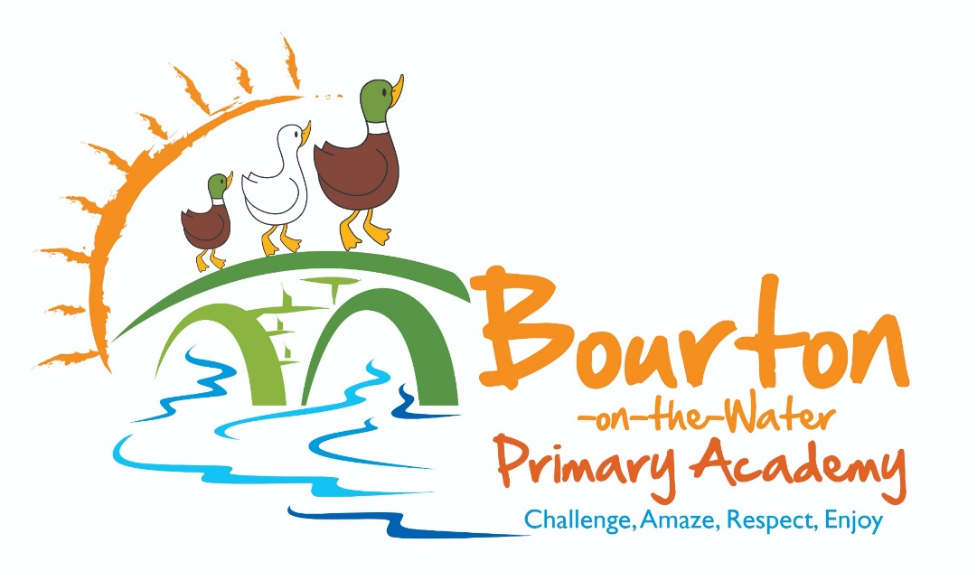

Information for New YR Parents

Welcome to Bourton-on-the-water Primary Academy
Starting school is a big step for your child and we hope to make it a very happy time for everyone. We aim to make every day in Reception an enjoyable, exciting and interesting time where your child can discover, learn and play. Young children develop most when they have opportunities to pretend, practise, explore, create, think and enjoy through a range of activities. Our classroom is organised into different areas so the children can access the resources and materials they need to develop their play.
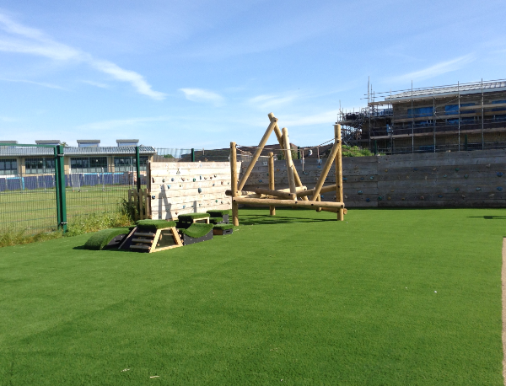
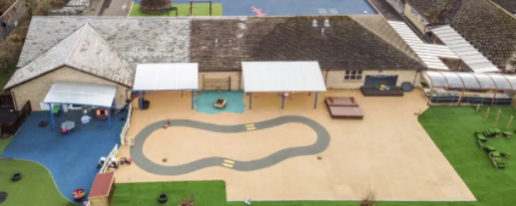

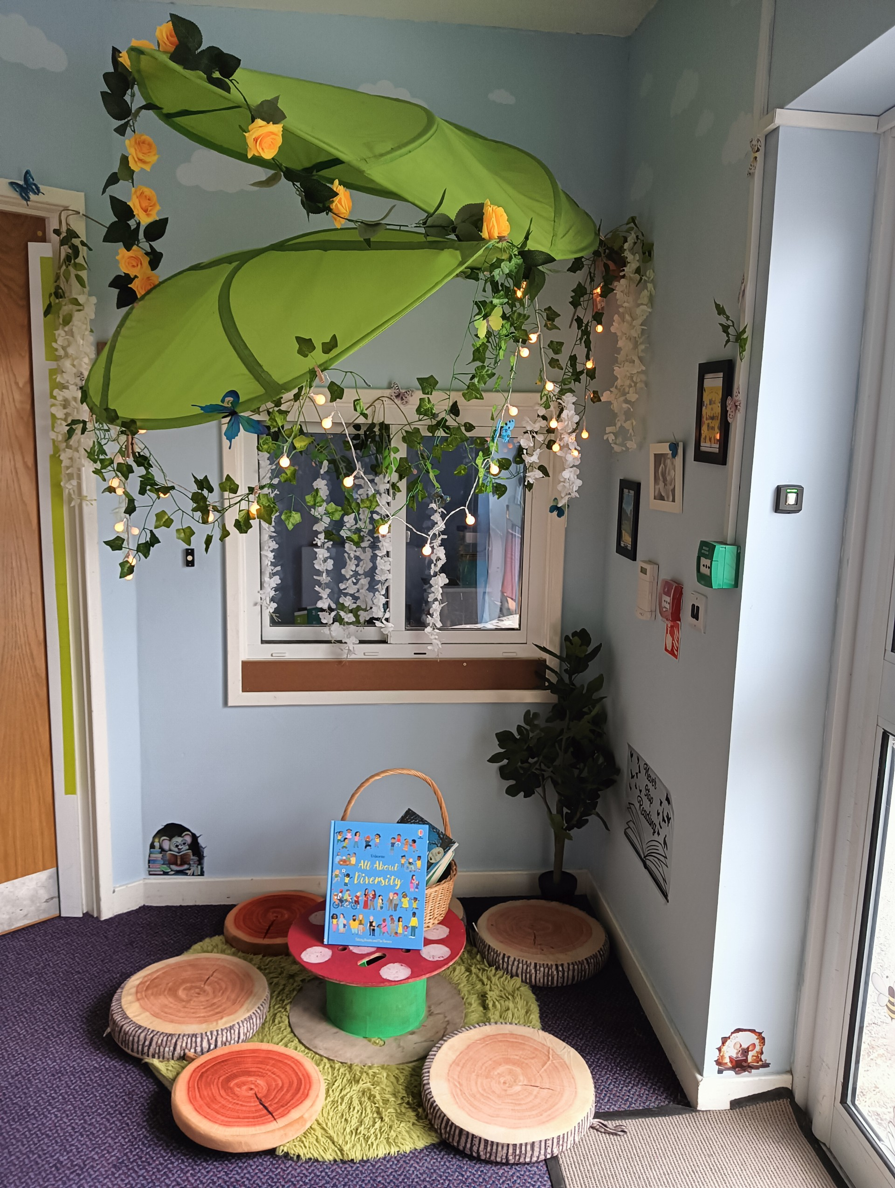
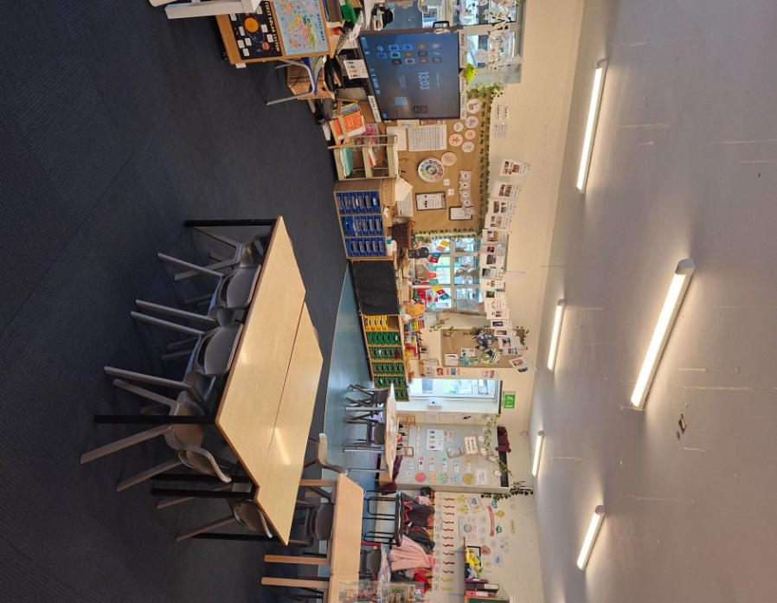

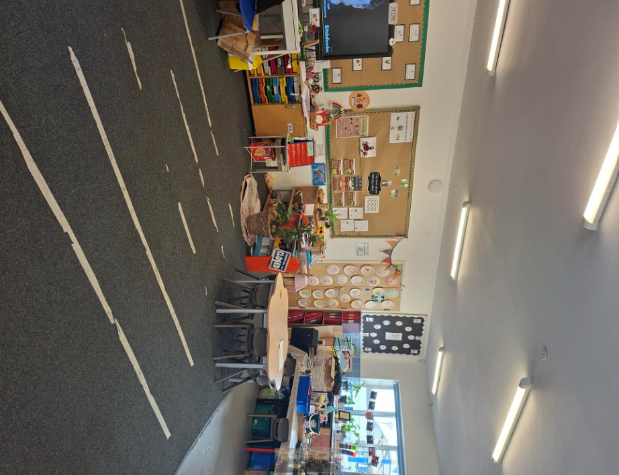

Early Years Foundation Stage Curriculum
The Early Years Foundation Stage (EYFS) curriculum follows on from a child’s preschool setting. This means that your child’s transition from pre-school to Reception shouldn’t involve great changes in the style of education they receive. A practical, play-based learning environment is central to the Early Years curriculum.
The seven key areas of learning are:
Communication and language
Personal, Social and Emotional Development
Physical Development
Literacy
Mathematics
Understanding the World
Expressive Arts and Design

The EYFS gives children the broad range of knowledge and skills that provide the right foundation for good future progress through school and life.
The children explore these areas of learning in many ways. These include whole class teaching, small group work with an adult, independent work, and through playing with carefully selected activities chosen by the adults in Reception. The children spend a lot of time learning through play as this is believed to be the best way for young children to learn. We do not make a difference between play and work as the children themselves don’t see the difference. We ensure that children learn through all the activities they participate in during their time in school. The children have opportunities to learn both indoors and outdoors, and we use the outdoor areas whatever the weather!

Communication and Language
Communication and Language helps children to improve their listening and speaking skills as well as their ability to follow instructions. We share rhymes and stories and give children lots of opportunities to speak and listen through their chosen activities. Children are supported to explain and predict what is happening and why, as well as encouraged to tell stories through their play.

Personal, Social and Emotional Development
Personal, Social and Emotional Development helps children to develop confidence, work in groups, play kindly and take turns. We support children to make friends, help them to feel good about themselves and praise positive behaviour.

Physical Development
Physical Development helps children to improve their skills of coordination and control in large and small movements including using a pencil for writing. It also teaches children to know how to be healthy and stay safe. We promote healthy food choices and discuss the effect of exercise on their bodies. There are structured PE and handwriting sessions as well as resources to promote these skills in our classroom and outdoor area.

Literacy
Literacy helps children learn to read and write. We want children to develop a lifetime love for reading. Books are read and discussed frequently to help children and we send home a picture book each day for you to read at home. We follow a daily structured phonics programme to teach children the letters and sounds which make up words. This helps them learn to read and spell. In Bourton school we use READ WRITE INC PHONICS.

Mathematics
Mathematics helps children learn to develop a deep understanding of number. We provide daily maths lessons which supports children to recognise groups of numbers without counting (subitising), counting, comparing amounts and the composition of different numbers (for example 5 is made up of a 3 and a 2).

Understanding the World
Understanding the world lays the foundations for history, geography, science and technology. We share and celebrate a range of festivals, help children to find out about the environment and their community.

Expressive Arts and Design
Expressive Arts and Design lays the foundation or art, design, music, dance and drama. We provide a range of resources to support creativity through their play including junk-modelling, drawing, construction and role-play. We dance and sing daily.

Practical Preparations for School
It would be extremely helpful if your child can do the following tasks before they start school.
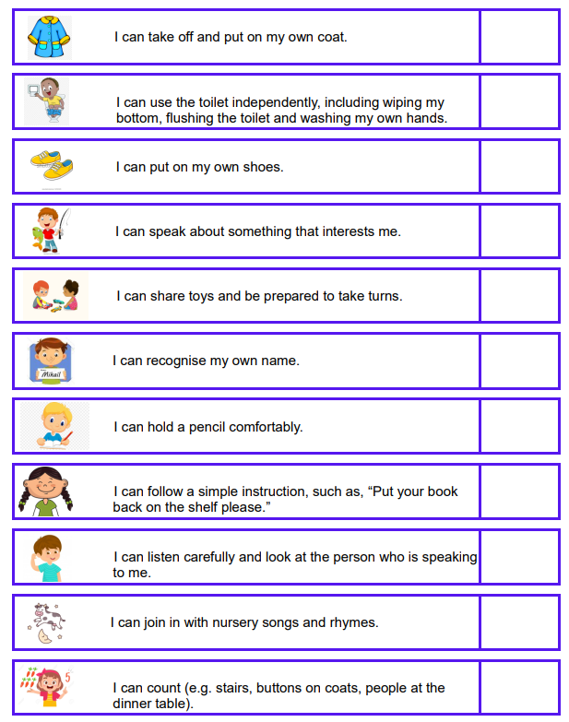

All children develop at different rates and in different ways so please don’t worry if your child is not able to do all of these things! These skills will very much be a focus of our transition into school and will be worked upon frequently.
SNACK TIME
In the Reception class, we have snack time every day. Snack time is a very important part of the curriculum when children can practice social conversation and listening skills. Snack time always includes a piece of fruit and a drink of either milk or water. We are part of a free fruit scheme which means that each child is able to have a piece of fruit at no cost to you. Through this scheme the children get to try a variety of fruit and vegetables.



LUNCHTIME
Children in Reception are entitled to free school meals. If you would like your child to have these then please fill out the free school meals letter in your Reception pack and return it to the school office. Menus will be on Aspens for you to choose your child’s choices. If you have any questions please see the office for more details. If your child chooses to bring a packed lunch please be aware that children should have healthy food in their lunch box. We also ask that the lunch is free from nuts due to children with severe allergies within the school.

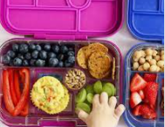

WATER BOTTLES
Your child will be expected to bring in a named re-usable/ sports water bottle each day (water recommended).


THINGS YOUR CHILD NEEDS TO BRING TO SCHOOL
All school clothes (and shoes!) named.
Named lunch box (if having packed lunch).
Named drinks bottle (water recommended).
Wellingtons boots which can be kept in school.
Named PE kit.
Apron (optional).
WE WILL PROVIDE A BOOK BAG.
Please click the link to find more information about the school uniform:
Bourton-on-the-Water Primary School - Uniform

ABSENCES
If your child is absent from the Class due to illness, please ring or email school to inform us on the first day of absence.
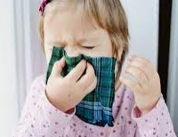

EACH DAY WHEN YOUR CHILD COMES HOME
Talk to them about things that they have done that day and how much they have enjoyed it. Praise any mark making or pictures brought home by your child. Read stories and rhymes to your child and let them join in. Encourage children to also make up their own stories too when playing with toys, ask who is their character, where is the setting, etc. Make everyday jobs into a game so that your child can enjoy them more, e.g. laying the table, emptying the washing machine, matching socks and planting seeds in the garden. We have booklets available to you with ideas of how to help your child at home with reading, writing and maths.

RECEPTION CLASS TIMETABLE
(This is an example)
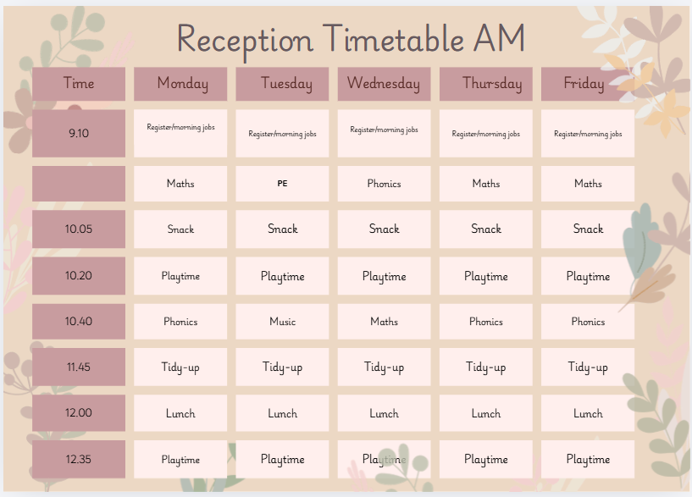

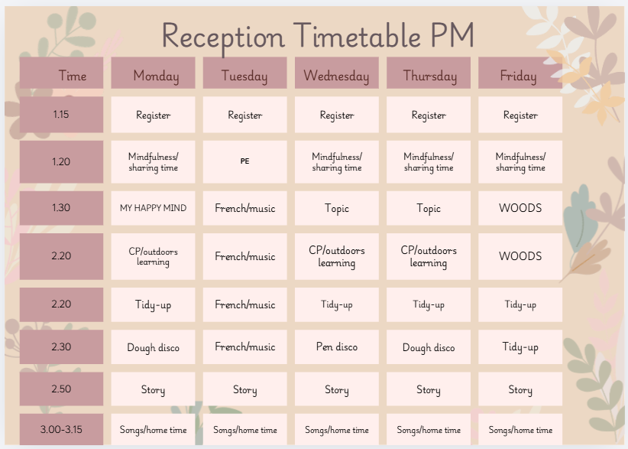

COMMUNICATION BETWEEN HOME AND SCHOOL
IPAL
IPAL is our preferred method of communication. You will receive a letter/email telling you how to register and then the school will send you information via IPAL.
We will occasionally send letters home via book bags, so do please check them every day.
Parents’ Evenings
Parents’ evenings will take place twice a year. These will be opportunities for a more formal review of your child’s progress. A report will be issued in the summer term.
Newsletter
Weekly newsletters are e-mailed via the IPAL system every Friday. These provide articles on what has happened during the week and also give information on events that are due to happen the following week. We encourage you to browse through the newsletter to ensure you do not miss anything important.
Website
Bourton-on-the-Water Primary School - Home

The website holds important information such as term dates, previous newsletters, copies of letters sent out and curriculum information, as well as photographs of each class participating in a variety of activities.

Contact Us

Bourton-on-the-Water Primary Academy
Address: School Hill, Bourton-on-the-Water, Cheltenham Gloucestershire GL54 2AW
Tel: 01451 820458
Email: admin@bourton.school

Mags Rogers (9am - 4pm)
Email: attendance@bourton.school
Kim Clayton (9am – 1.30pm)
Email: kclayton@bourton.school

Mags and Kim, work in our busy school office. They are all very helpful and will be able to point you in the direction of anything you might need, concerning invoicing, attendance, school records, premises, admissions and school appeals.

