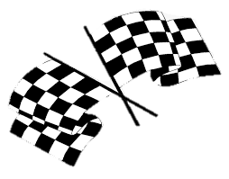
Year 5/6 Homework Activities Summer – Need For Speed!
Geography |  | History | PE
Electric cars will become the main mode of transport.  How is this going to impact Bourton?  Think about:  - Physical changes to the village to accommodate them  - Changes to economy and tourism  Write and draw diagrams to explain the changes. |  | Research the history of grand prix racing around the world.  Where did it come from?  How long has it been around?  Is it present in all countries?  Present your information in any way (fact file, powerpoint, poster) | Racing drivers need to be physically fit.  Create a fitness program and a healthy diet to enable an aspiring F1 driver to reach the level of fitness they need.
Art | Literacy |  |  | Science
Design a futuristic car which is eco-friendly.  Produce a colourful art piece depicting your invention. | Consider your futuristic car design.    Create a persuasive poster which would  encourage people  to purchase your  invention. |  |  | Investigate a famous innovator.  What have/did they invented?  Why is/was it useful?  How did they beocme an inventor?  Create a poster or fact file to present your informaiton.

Homework is due in by Monday 6th July to enable us to share this work in the final week of our topic.
We expect everyone to complete a minimum of 4 of these activities.
Remember other ongoing homework, such as reading and TTR.
If you need help sourcing anything to complete any of the homework tasks please speak to your class teacher.



