Newsletter

Dear Parents/Carers,

Welcome back to the start of the summer term.

This week we are very pleased to be able to share with you the results of our recent Ofsted inspection. This inspection was under the new framework you may have seen recently in the media. Therefore, it will look different to previous Ofsted reports that you may have seen.

The report card you can see below indicates the overall gradings we have achieved. If you also follow the link, you will have access to the full report and you can read more about the findings and where each grading was given. Inspection Report
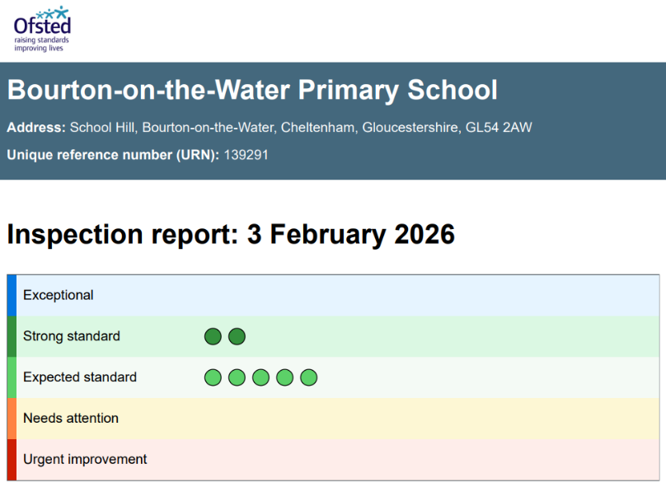

We feel that the final report reflects a true and honest outcome of a school we are very proud of. To achieve strong standards in Personal Development & Well-being and Behaviour & Attendance is representative of the children and the community that we are all part of.

We hope you enjoy reading the report and agree with us that the report itself highlights the many positives of our school community. There are of course action points for us to consider as we continue to move the school forward.

Thank you all for your continued support, we could not do this without you and your amazing children each day.

Kind regards,
Mrs Kilbey & Mrs Connor
Co Headteachers

