
Year 5 Homework Activities Summer 1: The World in Our Home
Geography |  | Literacy | History |  | DT
Research what businesses/countries are doing to tackle climate change.  Create a poster/fact sheet to present your findings. |  | Write an acrostic poem using key vocabulary from our topic.  eg resource, synthetic, latitude, circuit, command etc  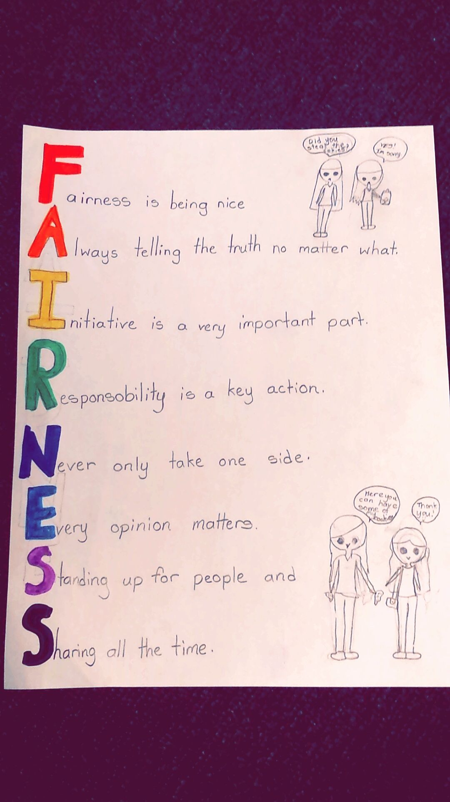 | Choose a mode of transport used in the past and create a timeline to show its evolution.  - When was it invented?  - How has it changed over time?  - What does it look like today? |  | Design a mode of transport which is eco-friendly.  Draw your creation and label with:  - Materials  - Exciting features  - How it moves  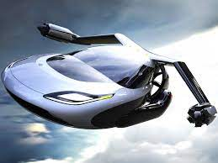
Music | Science |  |  | Art | PSHCE
Research and survey the range of music genres listened to in your home.  Eg. Pop, classical, rock, etc    Present your findings however you would like: tally chart, powerpoint presentation, poster etc | Investigate the electrical products in your home. Create a venn diagram showing which use batteries and which uses mains supply.  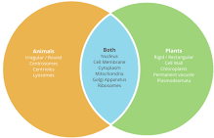 |  |  | Create an art piece/sculpture of your own home out of recycled materials.  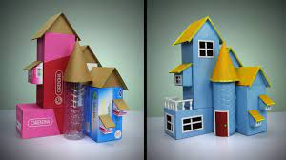  Make sure your recycled products are clean! | Where is your favourite place in your home? Think about why?  Draw a picture of you in your favourite place and give 5 reasons why it is so special to you.
Homework is due in by Monday 1st June, after the half-term break. We expect everyone to complete a minimum of 5 of these activities.
Remember other ongoing homework, such as your spelling & home reading.
If you need help sourcing anything to complete any of the homework tasks please speak to your class teacher.

