Year 3/4 Homework Grid
Incredible Inventions

Due in: Monday 13th April
You can choose which tasks to complete. Year 3’s must complete 4 tasks, and Year 4’s must complete 5. Remember to try your absolute best!
Reading, TTRS and spelling practice should also be completed 3 times per week.

Computing  Use BBC dance mat typing to practise your typing skills. Try and complete level 3.  If you don’t have access to a computer or tablet you could do the activity in school. | Science  Make a paper airplane and measure how far it can fly. How can you improve it to make it fly further? Record your results in a table. | DT  Invent a new type of vehicle. Think about what it does that makes it better than the vehicles we see on the road today.
Literacy  Interview a friend or family member and write a biography of their life. | 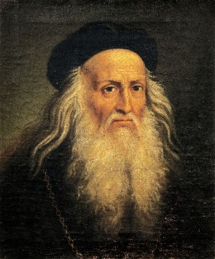     | History  Create a timeline of marvelous inventions!
RE  As Christians will be celebrating Easter, have a go at creating an Easter garden.  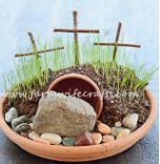 | DT  Research gears and create your own gear out of recycling or objects around the house. | Art  Da Vinci enjoyed filling sketchbooks with drawings plants and flowers. Create your own sketches of plants or flowers showing their detail.
Reading x3 a week | Spelling x3 a week | TTRS x3 a week

