Bourton-on-the-Water Primary Academy Safeguarding Team 2025
Are you concerned about a child?

Keeping children safe is everybody’s responsibility. If you are a member of staff, please log any concern via the My Concern website where they will be flagged to the DSLs, or if urgent, directly to a DSL.
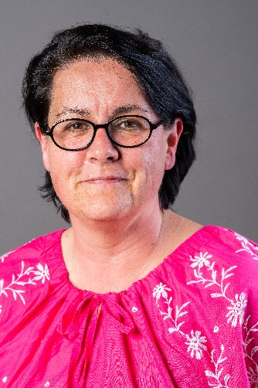
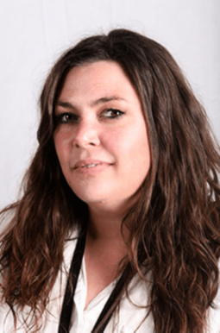
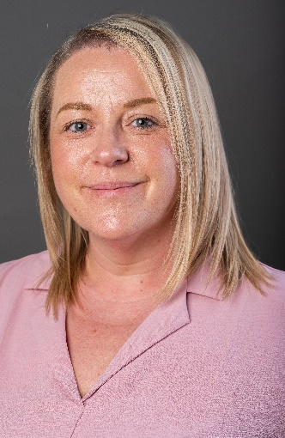
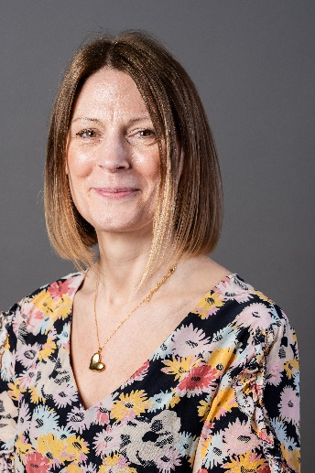
If you are a member of the public, you can call Children and Families Front Door Service on 01452 426565 (Monday to Friday 9am to 5pm). You can also discuss your concerns with someone who works in school – our safeguarding team are below:
Lindsay Connor Jo Kilbey Lisa Sorley Liz Hamilton
Co Headteacher Co Headteacher Pre-school Manager Parent Support Advisor
DSL DSL Pre-school DSL DDSL
Family worries…
Unsafe behaviour…
Social Media…
Substance abuse…
Self-harm…
Need someone to talk to?



I’m worried about a friend
I need help

Our Safeguarding Governor is Amy Howarth
In order to manage allegations against child care professionals, every Local Authority appoints a Local Authority Designated Officer (LADO).
In Gloucestershire the LADO is Nigel Hatten, who is supported by Tracy Brooks, the Allegations Management Co-Ordinator. Nigel can be contacted on 01452 426994 or nigel.hatten@gloucestershire.gov.uk

